Development Traceability Matrix

for

Online Rating System

Prepared by Sandeep Kumar

Guided by Prof. Amit Kumar (CSE Dept.)

NIIT University

Date:19 Sept 2016

Development Traceability Matrix:

|  |  |  |  |  |
| --- | --- | --- | --- | --- |
|  | Use Case Addressing Requirement | Classes Addressing The Requirement | Methods Addressing The Requirement | Unit Test Cases Addressing The Requirement |
| 4.1 | UC-1 |  |  |  |
| 4.2 | UC-2 |  |  |  |
| 4.3 | UC-3 |  |  |  |
| 4.4 | UC-4 |  |  |  |
| 4.5 | UC-5 |  |  |  |

|  |  |
| --- | --- |
| Use Case ID | Requirement Name |
| UC-1 | 4.1 |
| UC-2 | 4.2 |
| UC-3 | 4.3 |
| UC-4 | 4.4 |
| UC-5 | 4.5 |

**4.1** Create Account

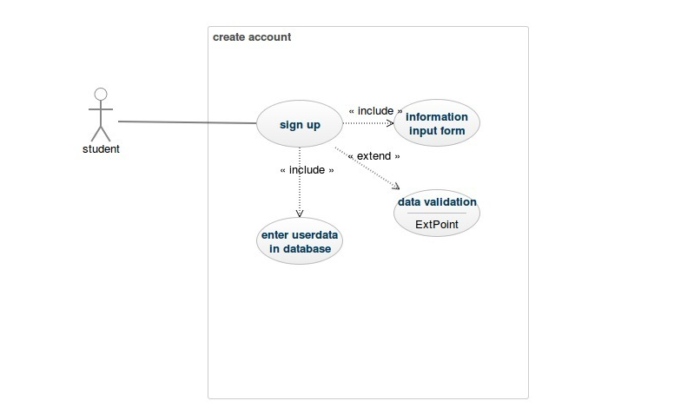

**4.2** Login Account

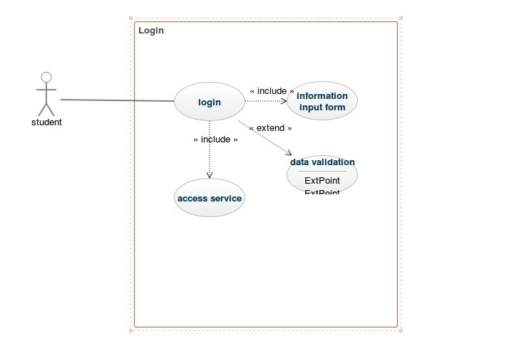

**4.3** Give Rating and Review about the concerned services

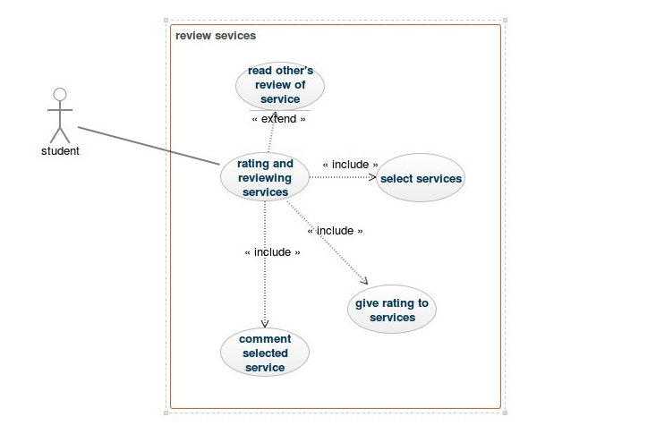

**4.4** Upvote/Downvote & Comment On Reviews.

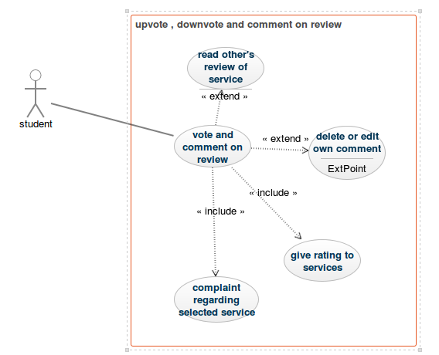

**4.5** Sending Review Summary to the concerned organization.

